COMSATS UNIVERSITY ISLAMABAD, LAHORE CAMPUS



Name: Abdul Wahab

Registration No: FA22-BSE-160

Class: Object Oriented Programming

Assignment: Lab Task 07

Teacher: Mam Mamoona Tassaduq

Date: 11th April 2023

Task 1:

Make a class Address that has two private attributes city and country and one fully

parametrized constructor.

Make a class Person that has two private attributes name and address. Attribute address should be of type Address. This class has a fully parameterized constructor.

Make another class Student. Class Student is inherited from class Person. This class has three private attributes program, year, and fee. It has one fully parametrized constructor.

Make a class Staff that is inherited from class Person. This class has one attribute which is pay and has one fully parameterized constructor.

In a test class, create one object for the Student and one for the Staff. Ask the user to input all information of a Student and Staff and print values of all attributes.

All attributes are private.

**CODE:**

import java.util.Scanner;  
  
public class Lab7_Task1 {  
  
 public static void main(String[] args) {  
  
 //Taking User Input  
 Scanner input = new Scanner(System.*in*);  
 System.*out*.print("Enter The Asked Information:\n");  
 System.*out*.print("Enter Student Name:");  
 String name = input.nextLine();  
 System.*out*.print("Enter City:");  
 String city = input.nextLine();  
 System.*out*.print("Enter Country:");  
 String count = input.nextLine();  
 System.*out*.print("Enter Program:");  
 String prog = input.nextLine();  
 System.*out*.print("Enter Year:");  
 int year = input.nextInt();  
 System.*out*.print("Enter Fees:");  
 int fee = input.nextInt();  
 input.nextLine();  
 System.*out*.print("Enter Staff Information:\n");  
 System.*out*.print("Enter Name:");  
 String Sname = input.nextLine();  
 System.*out*.print("Enter City:");  
 String sCity = input.nextLine();  
 System.*out*.print("Enter Country:");  
 String scount = input.nextLine();  
 System.*out*.print("Enter Pay:");  
 int Spay = input.nextInt();  
  
 //Creating Objects Here  
 Address add = new Address(city,count);  
 Address Sadd = new Address(sCity,scount);  
 Student stu = new Student(name,add,prog,year,fee);  
 Staff staff = new Staff(Sname,Sadd,Spay);  
 //Printing The Info Here  
 System.*out*.println();  
 System.*out*.println("Student Info:");  
 System.*out*.println("Name:"+stu.getName());  
 System.*out*.println("City:"+stu.getAdd().getCity());  
 System.*out*.println("Country:"+stu.getAdd().getCountry());  
 System.*out*.println("Program:"+stu.getProgram());  
 System.*out*.println("Year:"+stu.getYear());  
 System.*out*.println("Fees:"+stu.getFees());  
 System.*out*.println();  
 System.*out*.println("Staff Info:");  
 System.*out*.println("Name:"+staff.getName());  
 System.*out*.println("City:"+staff.getAdd().getCity());  
 System.*out*.println("Country:"+staff.getAdd().getCountry());  
 System.*out*.println("Pay:"+staff.getPay());  
  
 }  
  
}  
  
class Person {  
  
 private String Name;  
 private Address add;  
  
 public Person(String name, Address add) {  
 Name = name;  
 this.add = add;  
 }  
  
 //Getter Setter Here  
  
 public String getName() {  
 return Name;  
 }  
  
 public void setName(String name) {  
 Name = name;  
 }  
  
 public Address getAdd() {  
 return add;  
 }  
  
 public void setAdd(Address add) {  
 this.add = add;  
 }  
}  
  
class Address {  
  
 private String City;  
 private String Country;  
  
 //Constructor  
  
 public Address(String city, String country) {  
 City = city;  
 Country = country;  
 }  
  
  
 //Getter Setter  
  
  
 public String getCity() {  
 return City;  
 }  
  
 public void setCity(String city) {  
 City = city;  
 }  
  
 public String getCountry() {  
 return Country;  
 }  
  
 public void setCountry(String country) {  
 Country = country;  
 }  
}  
  
class Student extends Person{  
  
 private String Program;  
 private int Year;  
 private int fees;  
  
 public Student(String name, Address add, String program, int year, int fees) {  
 super(name, add);  
 Program = program;  
 Year = year;  
 this.fees = fees;  
 }  
  
 //Getter Setter  
  
  
 public String getProgram() {  
 return Program;  
 }  
  
 public void setProgram(String program) {  
 Program = program;  
 }  
  
 public int getYear() {  
 return Year;  
 }  
  
 public void setYear(int year) {  
 Year = year;  
 }  
  
 public int getFees() {  
 return fees;  
 }  
  
 public void setFees(int fees) {  
 this.fees = fees;  
 }  
}  
  
class Staff extends Person{  
  
 private int Pay;  
  
 public Staff(String name, Address add, int pay) {  
 super(name, add);  
 Pay = pay;  
 }  
  
 public int getPay() {  
 return Pay;  
 }  
  
 public void setPay(int pay) {  
 Pay = pay;  
 }  
}

**OUTPUT:**

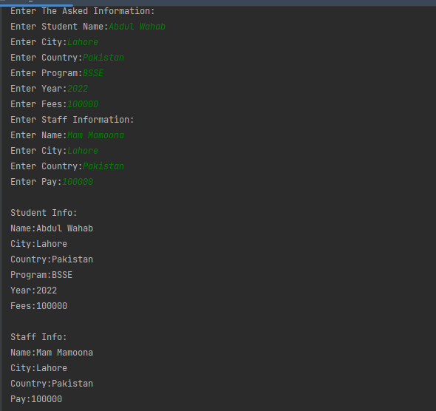

**Task 2:**

Note Put all classes in com.oop.inheritance package.

Make a class Circle that has two private attributes: color and radius. Create a fully

parameterized constructor. This class has a method calculateArea(), which calculates the

area of a circle. This class is inherited by Cylinder which has one private attribute height.

Create a fully parameterized constructor. This class (Cylinder) overrides calculateArea()

method.

In a test class, call the calculateArea() method of the Cylinder.

Area of Cylinder= 2(πr² + πrh)

Hint: πr²= Area of Circle

**CODE:**

package com.oop.inheritance;  
  
import java.util.Scanner;  
  
public class Lab7_Task2 {  
 public static void main(String[] args) {  
 Scanner scn = new Scanner(System.*in*);  
  
 //Taking Input  
 System.*out*.println("Enter Color:");  
 String color = scn.nextLine();  
  
 System.*out*.println("Enter The Radius:");  
 double rad = scn.nextDouble();  
  
 System.*out*.println("Enter Height:");  
 double hei = scn.nextDouble();  
  
 //Making Object and Passing Values  
 Cylinder cyl = new Cylinder(color,rad,hei);  
  
 System.*out*.printf("The Area of com.oop.inheritance.Cylinder is : %.2f",cyl.calculateArea());  
  
 }  
  
}  
  
class Circle {  
  
 private String Color;  
 private double Radius;  
  
  
 public Circle(String color, double radius) {  
 Color = color;  
 Radius = radius;  
 }  
  
 public String getColor() {  
 return Color;  
 }  
  
 public void setColor(String color) {  
 Color = color;  
 }  
  
 public double getRadius() {  
 return Radius;  
 }  
  
 public void setRadius(double radius) {  
 Radius = radius;  
 }  
  
 public double calculateArea(){  
  
 double area = Math.*PI*\*Radius*Radius;  
 return area;  
  
 }  
  
  
}  
class Cylinder extends Circle{  
  
 private double Height;  
  
 public Cylinder(String color, double radius, double height) {  
 super(color, radius);  
 Height = height;  
 }  
  
 //Getter Setter  
  
  
 public double getHeight() {  
 return Height;  
 }  
  
 public void setHeight(double height) {  
 Height = height;  
 }  
  
  
  
 public double calculateArea(){  
  
 double area = 2*(super.calculateArea()+Math.*PI*\*getRadius()*getHeight());  
 return (float) area;  
  
 }  
  
}

**OUTPUT:**

